Department of Veterans Affairs (VA)

Benefits Claims Decision Support System (BCDSS)

Software Installation Guide and Release Plan



**February 2017**

Version 1.0

Revision History

| **Date** | **Version** | **Description** | **Author** | **Reviewer** |
| --- | --- | --- | --- | --- |
| 2017-02-09 | 1.0 | No Updates | Vasu Rayapati |  |
| 2017-01-12 | 0.9 | No Updates | Vasu Rayapati |  |
| 2016-12-20 | 0.8 | No Updates | Vasu Rayapati |  |
| 2016-11-16 | 0.7 | Jenkins builds and deployments 5.2 | Vasu Rayapati |  |
| 2016-10-17 | 0.6 | No updates | Vasu Rayapati |  |
| 2016-09-20 | 0.5 | Editorial changes and updated links 4.2 | Jeffrey Bamba | Evan Weber |
| 2016-08-22 | 0.4 | No updated | Ganesh Panneer |  |
| 2016-07-18 | 0.4 | Release plan updates  6.0 | Vasu Rayapati |  |
| 2016-06-20 | 0.3 | Document updates | Vasu Rayapati | Rebecca Garcia DeJesus |
| 2016-05-16 | 0.2 | Document updates | Vasu Rayapati, Jeffrey Bamba | Erik Rothwell |
| 2016-04-20 | 0.1 | Template Create | Erik Rothwell |  |

Table of Contents

1 Introduction 4

1.1 Purpose 4

1.2 Scope 4

1.3 Assumptions and Dependencies 4

2 Environment Categories, Servers and Tomcat Instances 5

2.1 Tomcat Instances 5

2.2 Environment Categories 5

3 Prerequisites 6

3.1 Host Requirements 6

3.2 VM Requirements 6

3.2.1 VM Hardware Configuration 6

3.2.2 VMware Version 6

3.2.3 VM Guest OS Configuration 6

3.3 User Environment Settings 6

3.4 Application Software Prerequisites 6

3.5 Installing Apache Tomcat 6

4 Installing and Updating the BCDSS Databases 14

4.1 Script Components 14

4.2 Prerequisites 14

4.3 Database Installation Procedure 14

4.4 Database Update Procedure 25

4.5 Uninstall the BCDSS Database 25

5 Deploying the Application 26

5.1 Overall Pre-Deployment Assumptions 26

5.2 Builds and Deployments to Dev 26

5.3 Deployments to Pilot 27

5.3.1 Additional Pre-deployment Assumptions 27

5.3.2 Configure Deployment Properties 27

5.3.3 Deploy BCDSS 27

5.4 Verify Application Availability and Version 27

6 Release Plan 28

6.1 BCDSS Continuous Integration Process Flow 28

7 Appendices 30

Appendix A. Terminology 31

Appendix B. References 31

8 Attachments 32

Attachment A. Approval Signatures 32

# Introduction

This document describes how to prepare target platforms for the Benefits Claims Decision Support System (BCDSS) software and how to install and configure the software.

## Purpose

The purpose of this guide is to provide instructions for preparing platforms on the BCDSS software and for deploying the BCDSS application to a point where the application can be successfully run.

The installation described in this document is for a standalone instance of the BCDSS software.

## Scope

The scope of information in this document is the preparation of the platforms that will run all elements of the BCDSS software (e.g., database, web application, and related servers) and the installation of the BCDSS software to yield an operational system. This document will be kept current for the software produced in each sprint of the development cycle, as well as for each release of the product.

This guide assumes baseline virtual machines have been created with the appropriate OS, e.g., Windows, Red Hat Enterprise Server, 64-bit and application software, e.g., Apache Tomcat and Oracle database. The instructions in this guide deal with the configuration of the baseline VMs and the deployment of the BCDSS application.

## Assumptions and Dependencies

Users of this document are assumed to have a working knowledge of the target platform Operating Systems (OSs) and their native editors (for example, VI), and the Commercial-Off-The-Shelf (COTS) software applications used by the application.

# Environment Categories, Servers and Tomcat Instances

The BCDSS environment categories, servers, and tomcat instances are described in the sections that follow.

## Tomcat Instances

BCDSS dev and pilot application server instances are configured on the same server using separate copies of folders for each tomcat instance. These folders contain the actual scripts and code for the server.

## Environment Categories

The BCDSS application will be installed into the following environments per the release sprint life cycle:

* Dev
* Pilot

The platform architecture categories are depicted on the following pages.

# Prerequisites

This section describes the required hardware and software environments for the BCDSS applications.

## Host Requirements

The host servers that run the virtual machines where the BCDSS application is executed are the responsibility of the organization operating the FTL environment. Information about them is outside the scope of this manual.

## VM Requirements

The VM requirements specified in this section apply to all VMs.

### VM Hardware Configuration

The VM hardware configuration details are as follows:

* Virtual disk size: 550 GB
* Virtual memory allocation: 16 GB

### VMware Version

The VMware version number is as follows:

* VMware version:

### VM Guest OS Configuration

VA’s FTL team does VM configurations based on the help desk ticket.

## User Environment Settings

## Application Software Prerequisites

The following open source and COTS application software pertaining to the procedures of this installation guide are used in the BCDSS servers (Note: The software used varies according to the server type.):

* Apache Tomcat
* Oracle

## Installing Apache Tomcat

The Apache Tomcat software is developed in an open and participatory environment and released under the Apache License version 2. It powers numerous large-scale, mission-critical web applications across a diverse range of industries and organizations.

The following are installation instructions:

1. Download [**Apache Tomcat**](http://tomcat.apache.org/).
2. Extract into development tools folder,.e.g., C:\Tomcat\.
3. Create and configure the following Environment Variables:

* CATALINA_HOME, e.g., C:\Tomcat\
* JRE_HOME, e.g., C:\Java\x64\jdk1.8.0_45\jre
* JAVA_HOME, e.g., C:\Java\x64\jdk1.8.0_45

1. Start server by running **startup.bat** in **bin** folder.

#### Tomcat Folder Structure

* /bin : This directory contains the startup and shutdown scripts for both Windows and Linux.
* /conf : This directory contains the main configuration files for Tomcat. The two most important are the server.xml and the global web.xml.
* /server : This directory contains the Tomcat Java Archive files.
* /lib : This directory contains Java Archive files that Tomcat is dependent upon.
* /logs : This directory contains Tomcat’s log files.
* /src : This directory contains the source code used by the Tomcat server. Once Tomcat is released, it will probably contain interfaces and abstract classes only.
* /webapps : All web applications are deployed in this directory; it contains the WAR file.
* /work : This is the directory in which Tomcat will place all servlets that are generated from JSPs. If you want to see exactly how a particular JSP is interpreted, look in this directory.

#### Server Ports

The Tomcat ports configuration is essential to manage the multiple instances of the same server installation. The ports are used by tomcat for start-up, deployment and shut-down operations. The detail of each port is as:

* **Connector Port**: This is the port where Apache Tomcat listens for the HTTP requests.
* **Shutdown Port**: This port is used when trying to shutdown the Apache Tomcat Server.
* **AJP (Apache JServ Protocol) Connector Port**: The Apache JServ Protocol (AJP) is a binary protocol that can conduct inbound requests from a web server through to an application server that sits behind the web server.
* **Redirect Port**: Any redirection happening inside Apache Tomcat will happen through this port. In Apache Tomcat there are two instance where redirectPort is mentioned. The First one is for the Apache Tomcat server and the other one is for the AJP port.

#### Dev Environment Setup

1. Create a Dev Tomcat Instance in the **C:\Tomcat\tomcat_dev** folder.

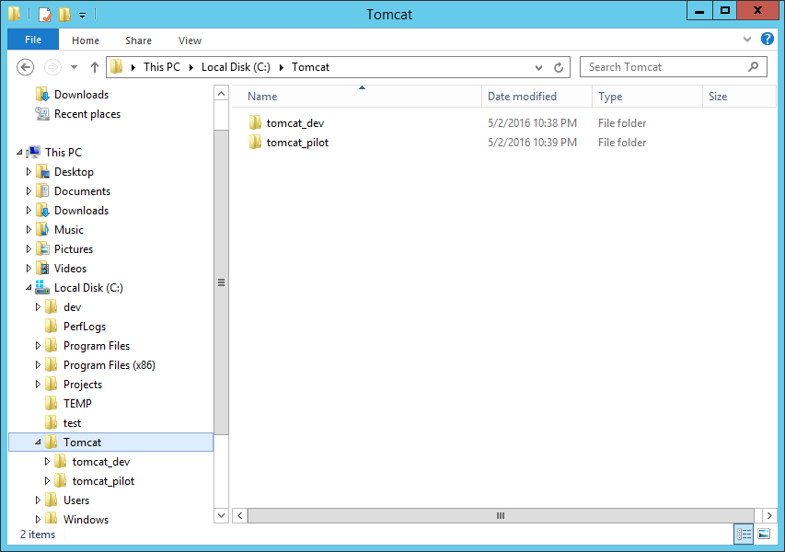

Figure : Dev Environment Tomcat Folder

1. Open the **tomcat_dev/conf/server.xml** file and change the **HTTP**, **HTTPS**, **AJP**, and **Shutdown Ports** as shown in Figure 2.

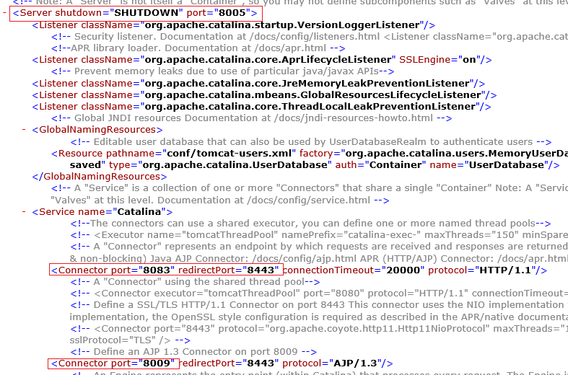

Figure : Dev Environment Server Configuration

1. Rename startup and shutdown scripts as shown in Figure 3.

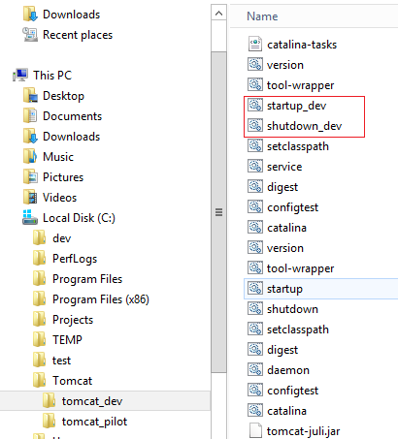

Figure : Dev Environment Scripts

#### Pilot Environment setup

1. Create a *Dev Tomcat Instance* under the **C:\Tomcat\tomcat_pilot** folder.



Figure : Pilot Environment Tomcat Folder

1. Open the **tomcat_pilot/conf/server.xml** file and change the **HTTP**, **HTTPS**, **AJP**, and **Shutdown Ports** as shown in Figure 5.

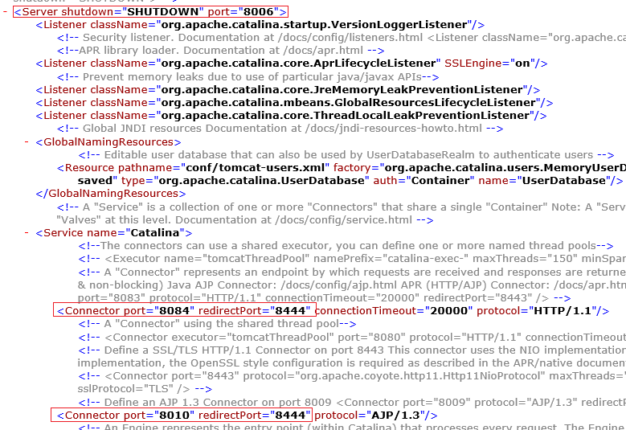

Figure : Pilot Environment Server Configuration

1. Rename startup and shutdown scripts as shown in Figure 6.

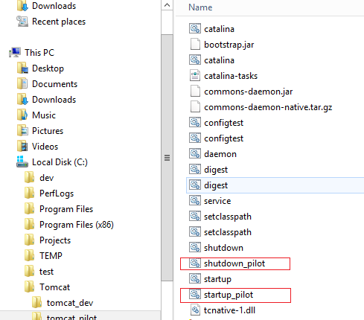

Figure 6: Pilot Environment Scripts

# Installing and Updating the BCDSS Databases

## Script Components

The following database script should be executed against the BCDSS database platform for creating all the database objects required to run the application:

* CreateBCDSSSchemaObject.sql

## Prerequisites

Oracle provides 32-bit (x86) and 64-bit (x64) versions of Oracle Database for Microsoft Windows. The 32-bit database version, which this installation guide describes, runs on the 32-bit version of Windows on either x86 or x64 hardware. Oracle provides limited certification for 32-bit Oracle Database Client on 64-bit Windows (x64). For additional information, visit My Oracle Support (formerly Oracle*MetaLink*) at: <https://support.oracle.com/>

Table 1: Minimum Hardware Component Requirements for Windows 64-Bit

| **Requirement** | **Value** |
| --- | --- |
| Physical memory (RAM) | 1 GB minimum |
| Virtual memory | Double the amount of RAM |
| Disk space | Total: 5.22 GB  See [Table 2-3](https://docs.oracle.com/cd/B28359_01/install.111/b32006/reqs.htm#CHDHHGBB) for details. |
| Processor | AMD64 or Intel Extended Memory (EM64T) |
| Video adapter | 256 colors |

## Database Installation Procedure

* 1. Download the software from **edelivery.oracle.com** and save the file in a folder.
  2. Extract files from the downloaded archive and double-click the setup.exe file. There is no need to supply any email address.
  3. Click **Next**.

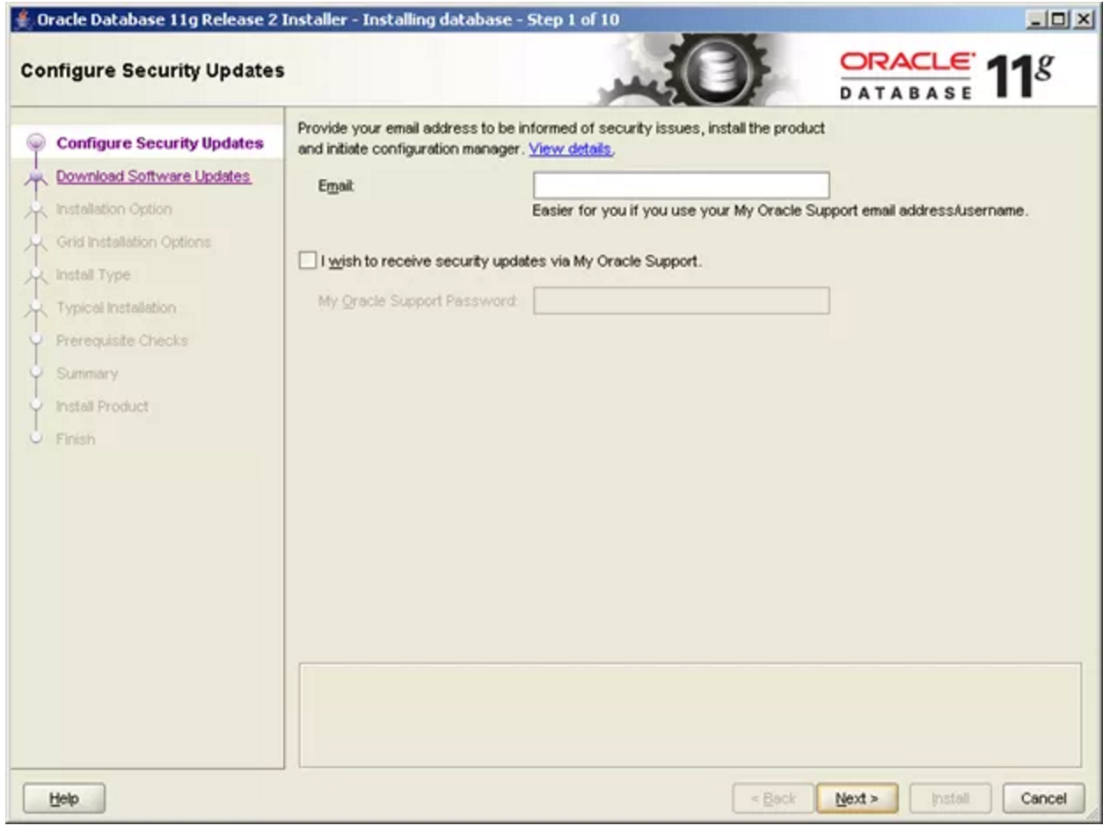

Figure : Oracle Installer Step 1

* 1. Click **Yes**.

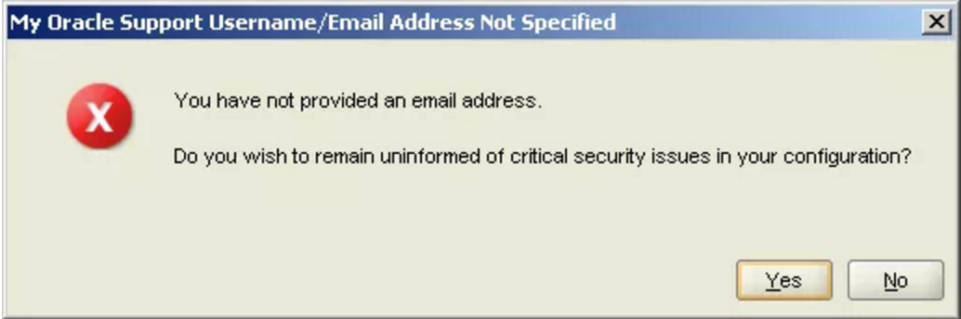

Figure : Username/Email Address Not Specified

* 1. Select **Skip Software Updates** and then click **Next**.

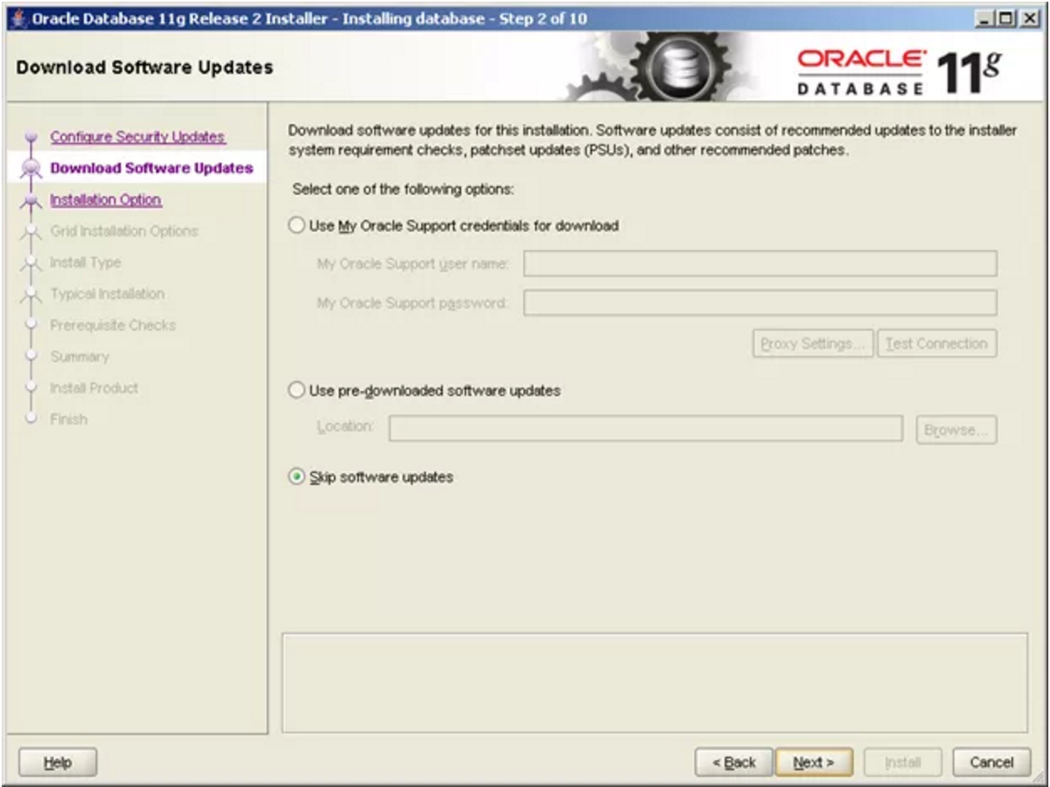

Figure : Oracle Installer Step 2

* 1. Keep the default settings as shown in Figure 10 and click **Next.**

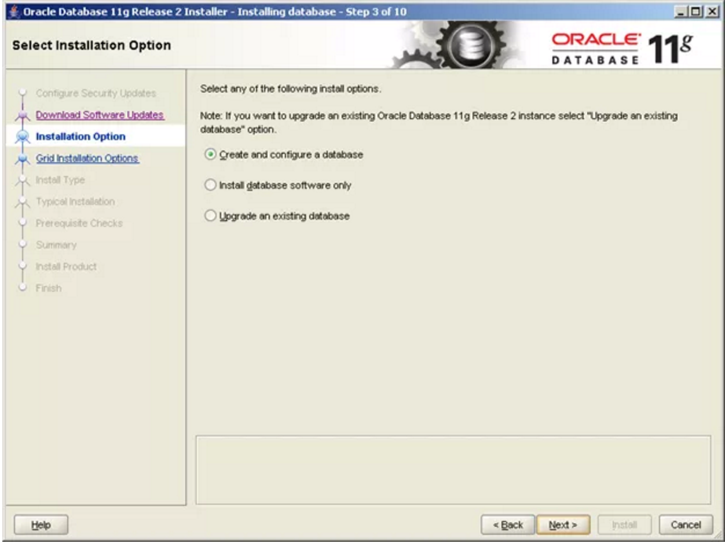

Figure : Oracle Installer Step 3

* 1. Select an option based on your requirement as shown in Figure 11. **Desktop Class** contains the normal standalone database and **Server Class** contains RAC, backup, recovery, etc. For illustrative purposes, the following steps presume **Desktop Class** was selected.

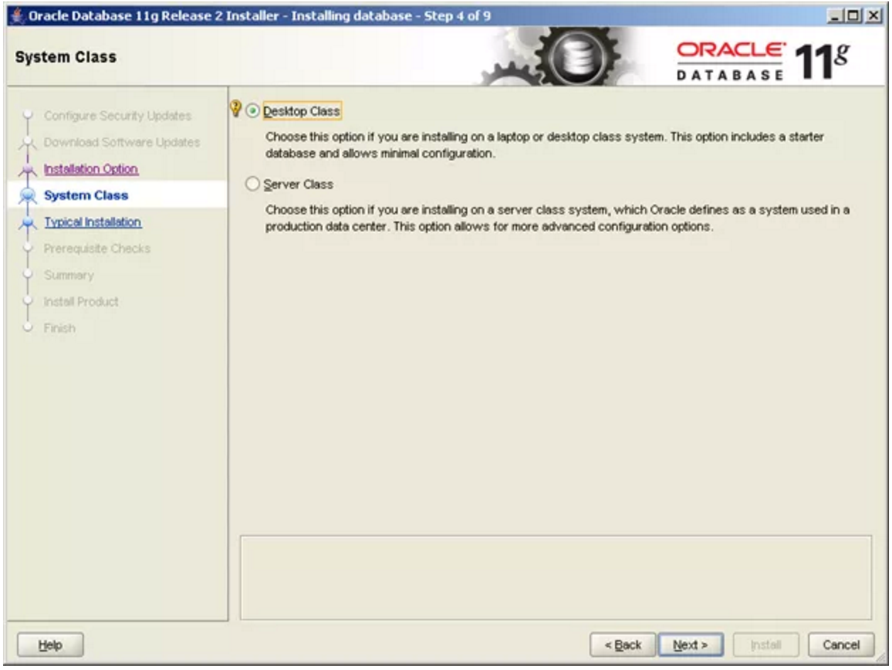

Figure : Oracle Installer Step 4

* 1. Fill out the details as shown in Figure 12 and click **Next**.

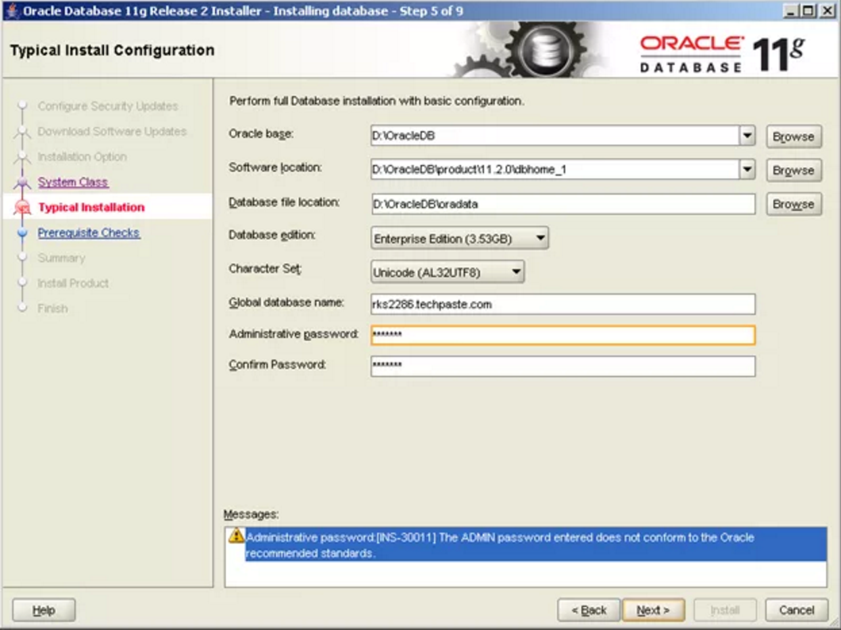

Figure : Oracle Installer Step 5

* 1. Wait until all checks are completed.

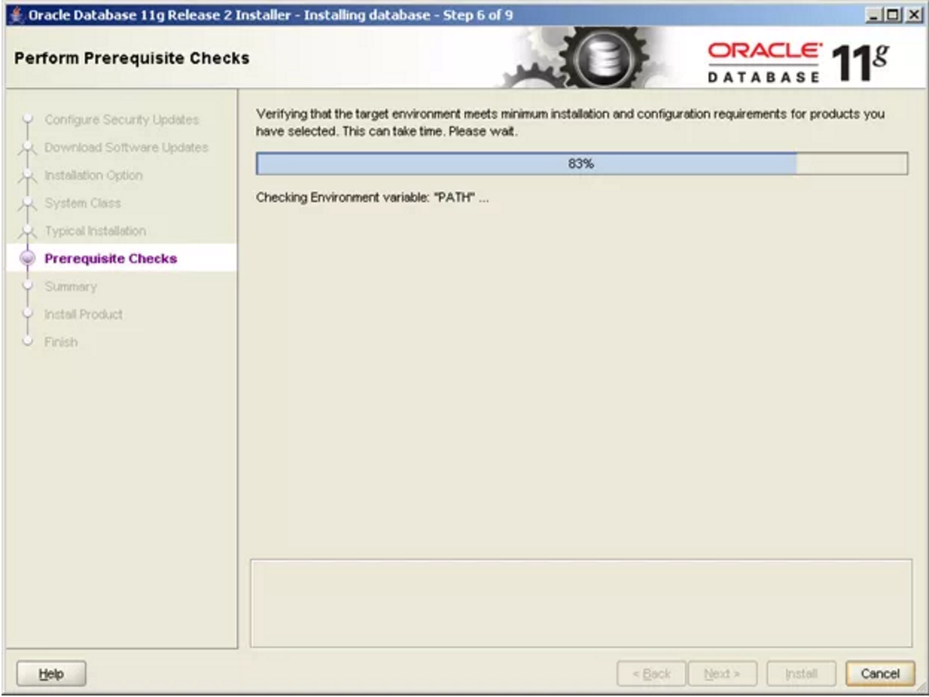

Figure : Oracle Installer Step 6

* 1. Click **Install** to start the installation.

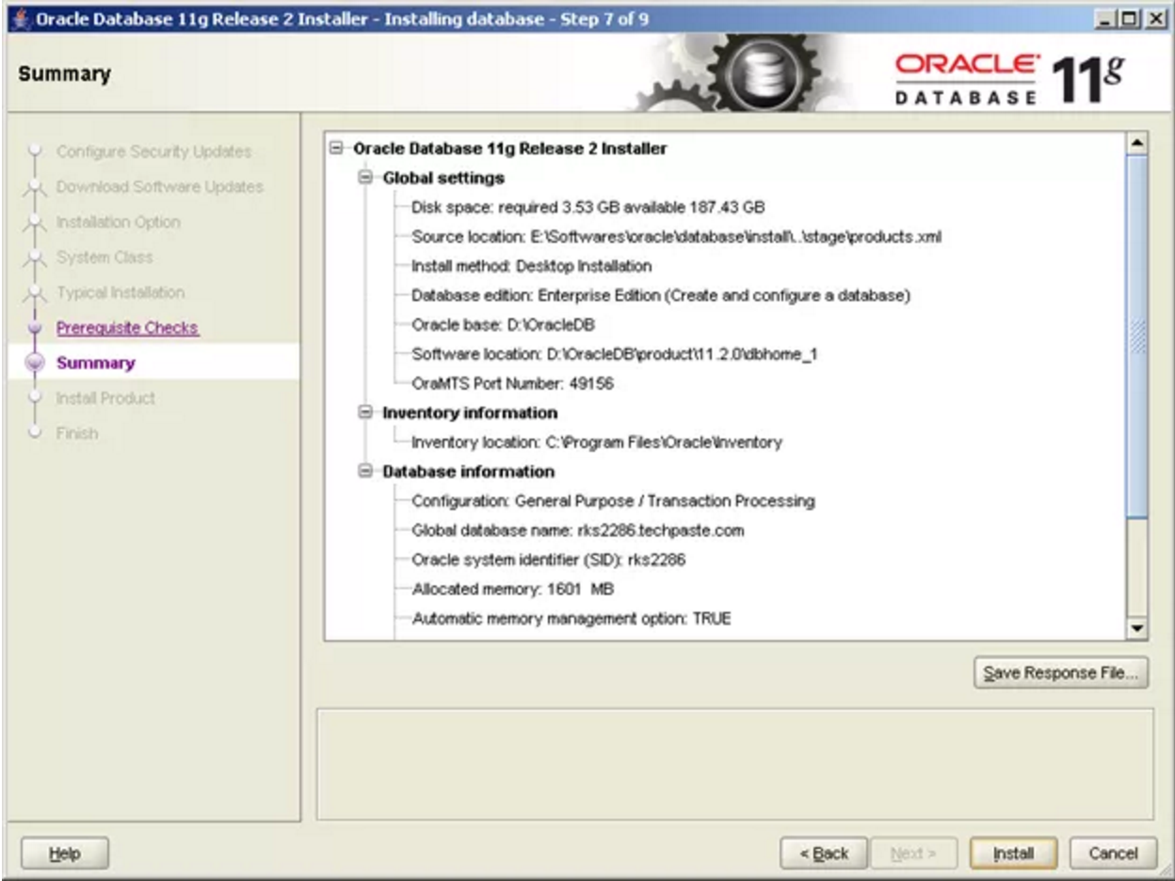

Figure : Oracle Installer Step 7

* 1. Wait for the installation to complete.

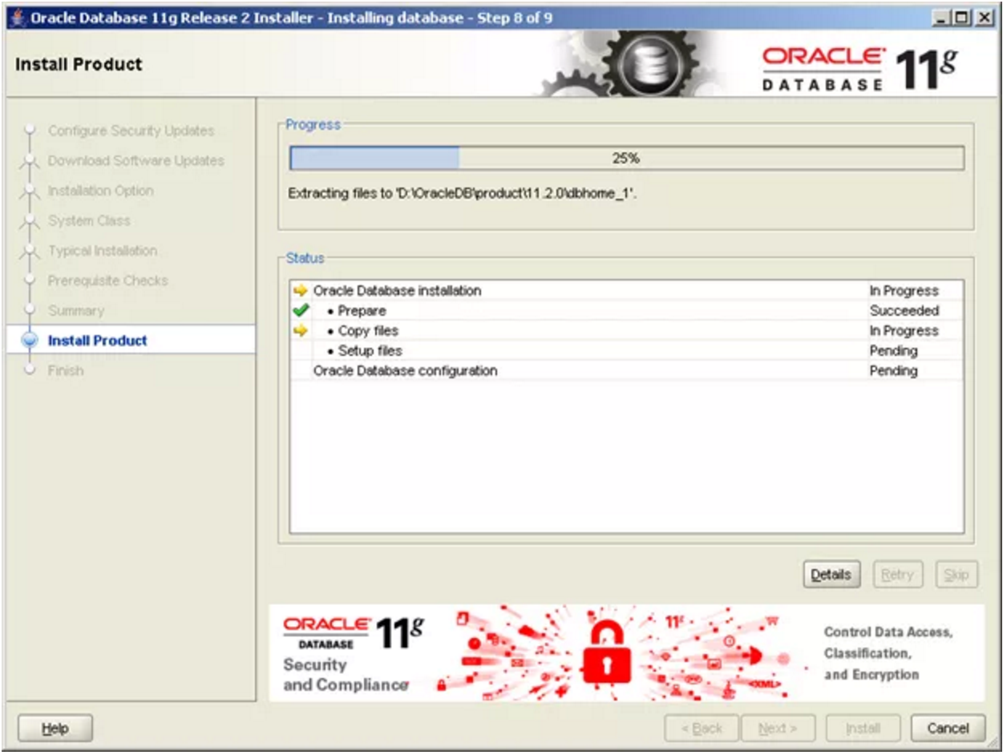

Figure : Oracle Installer Step 8

* 1. If any popups appear during the installation for permission to access the network, select **Yes** so that the installation can proceed.

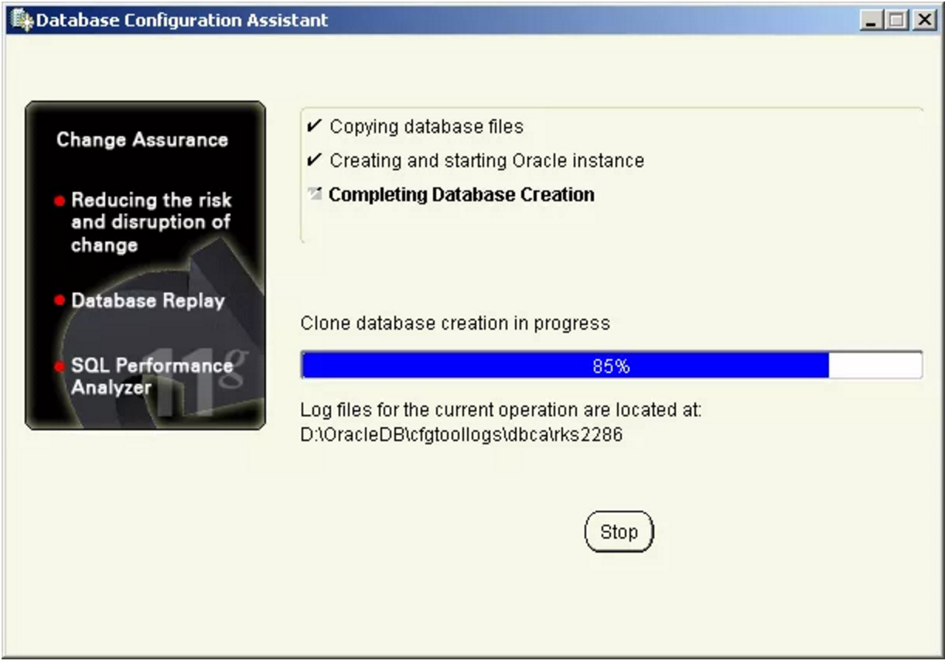

Figure : Database Configuration Assistant In Progress

* 1. When the screen shown in Figure 17 displays, click **OK**.

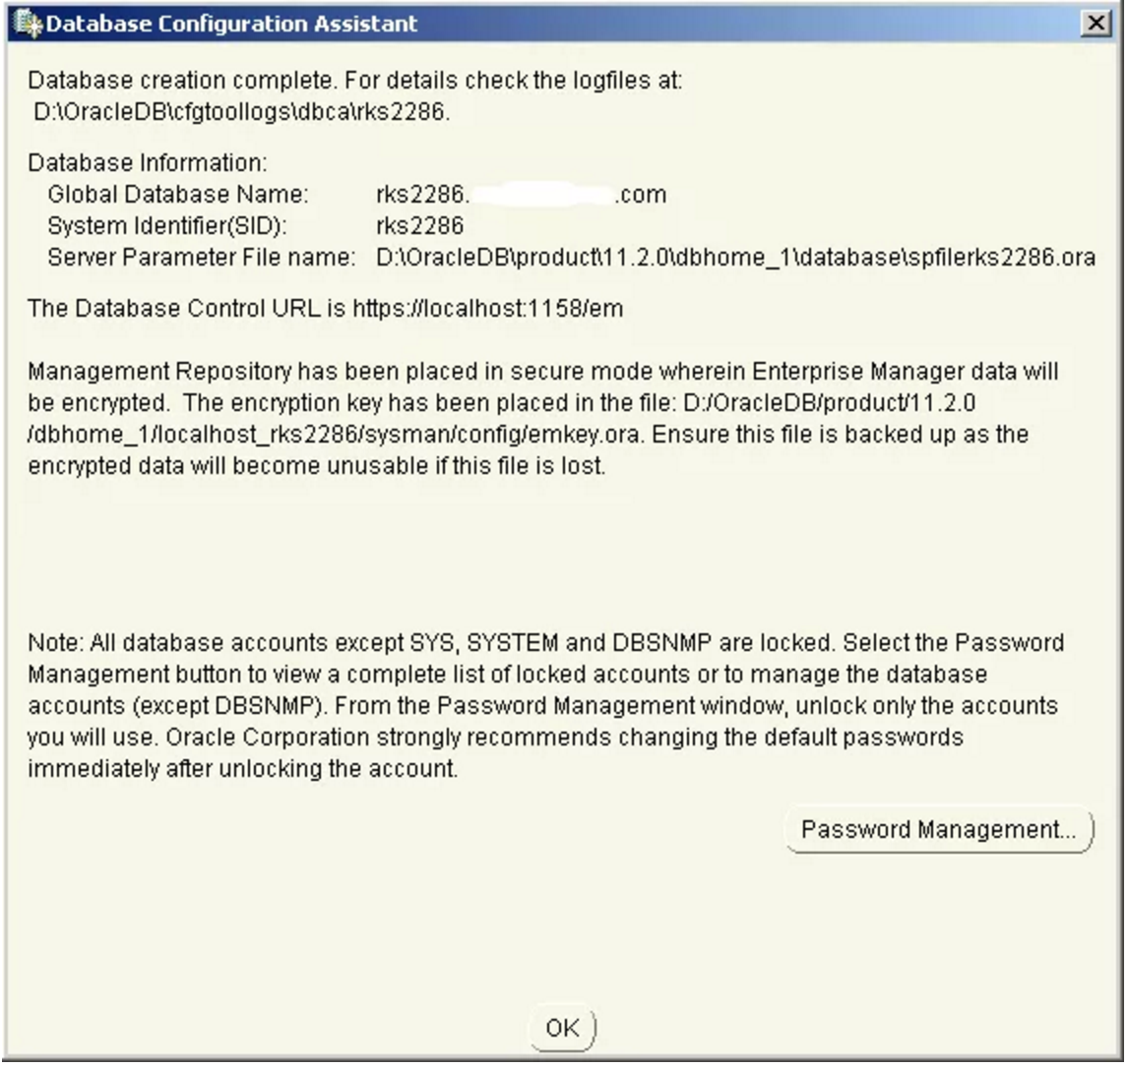

Figure : Database Configuration Assistant Complete

* 1. Click **Close** to complete the installation.

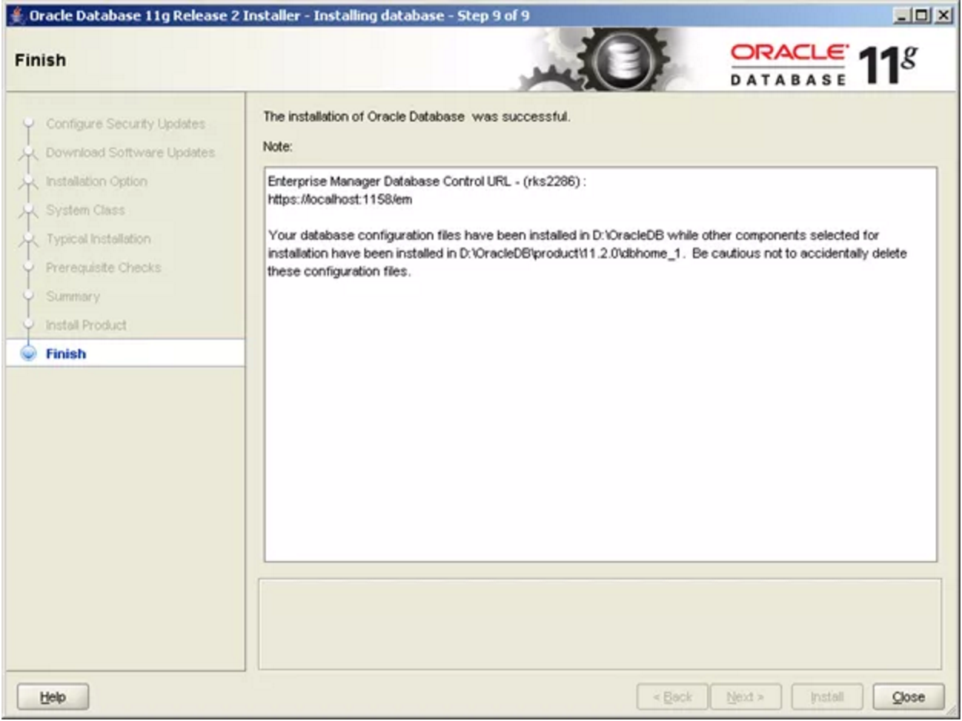

Figure : Oracle Installer Step 9

## Database Update Procedure

TBD

## Uninstall the BCDSS Database

TBD

# Deploying the Application

This section provides instructions for deploying the BCDSS application to the Dev and Pilot Environments.

## Overall Pre-Deployment Assumptions

The following conditions must be met before performing a BCDSS deployment:

* Upload the project artifacts (JAR, EAR files) to staging environment folder.
* Verify JAR and EAR files are loaded in the staging environment folder.
* Upload the project documentation deliverables to an internal directory workspace.
* Apply the Liquibase Database Change Logs to the target database. A Change set can be seen as everything needed to migrate from one version of the database to another.
* This requires corresponding SQL-statements that are grouped and then executed together.

## Builds and Deployments to Dev

Continuous Integration (CI) builds are automated through the Jenkins pooling task. Jenkins sends failure notifications to the development team for all build failures. CI build artifacts will be deployed on the Development Integration environment manually.

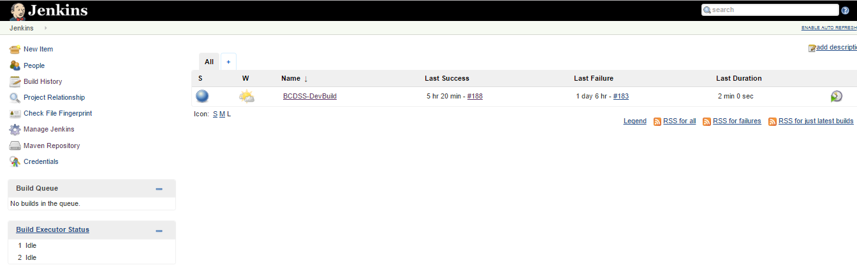

Figure : Dev Builds Dashboard

The BCDSS team uses the following tools for development integration environment deployments:

* Jenkins tool for Web application deployments
* Liquibase for database changes

## Deployments to Pilot

### Additional Pre-deployment Assumptions

* Update the Pilot database configurations in environment specific properties file.
* Upload the project artifacts (JAR and EAR files) to Pilot staging environment folder.
* Verify JAR and EAR files are loaded in the staging environment folder.

### Configure Deployment Properties

The profile based configuration file in the persistence /resources directory contains data source information. The standard build will utilize application-local.yml and update it to application-test.yml for the Pilot environment.

### Deploy BCDSS

Sprint candidate builds will be deployed to the Pilot environment manually at the end of the each sprint (every two weeks).

## Verify Application Availability and Version

Perform the following application sanity check steps:

1. Access the BCDSS application home page.
2. Login as a test user and verify the version number located in the footer.

# Release Plan

Table 2 provides the estimated release schedule for BCDSS application.

Table : Estimated BCDSS Release Schedule

|  |  |  |
| --- | --- | --- |
| **Release Number** | **Description** | **Estimated Release Date** |
| BCDSS v1.0 | First version of BCDSS | 19-Aug-16 |
| BCDSS v2.0 | Version 2.0 BCDSS Application | 25-Nov-16 |
| BCDSS v3.0 | Version 3.0 BCDSS Application | 20-Jan-17 |
| BCDSS v4.0 | Version 4.0 BCDSS Application | 14-Apr-17 |
| BCDSS v5.0 | Version 5.0 BCDSS Application | 14-Sep-17 |

## BCDSS Continuous Integration Process Flow

Continuous Integration (CI) is a process in which all development work is integrated as early as possible. The resulting artifacts are automatically created and tested. This process should identify errors very early in the process.

The BCDSS team is using the Jenkins open-source tool to perform continuous integration and build automation. The basic functionality of Jenkins is to execute a predefined list of steps. The trigger for this execution can be time or event based. For example, every 60 minutes or after a new commit in the GitHub repository.

Jenkins also monitors the execution of the steps and allows to stop the process if one of the steps fails. It sends out a notification about the build’s success or failure.

The below diagram explains BCDSS CI process flow.



Figure : BCDSS CI Process Flow

The development team will pick up user stories from a change management system and develop the code for an assigned task. Jenkins “watches” the Github repository for any code changes and automatically do a Maven build. Jenkins deploys the built artifact into the target Dev Integration Server (Tomcat), if the build is successful. The Quality Assurance (QA) team validates the build after each deployment.

The BCDSS release management team then deploys the sprint release candidate into the Pilot environment at the end of the sprint.

# Appendices

The following appendices supply additional information about this document.

1. Terminology

The following table lists the terminology used in this document.

|  |  |
| --- | --- |
| **Acronym** | **Definition** |
| BCDSS | Benefits Claims Decision Support System |
| CI | Continuous Integration |
| COTS | Commercial Off The Shelf |
| OS | Operating System |
| QA | Quality Assurance |

1. References

The following documents are referenced in this document and/or provide information that augments the information in this document:

# Attachments

1. Approval Signatures

This section is used to document the approval of the BCDSS Software Installation Guide during the Formal Review. The review should be conducted face to face where signatures can be obtained “live” during the review.

If unable to conduct a face-to-face meeting then it should be held via LiveMeeting and concurrence should be captured during the meeting. The Scribe should add /es/name by each position cited.

The Business Sponsor and Project Manager are required to sign.

REVIEW DATE:

SCRIBE:

______________________________________________________________________________

Signed: Date:

< Business Sponsor >

______________________________________________________________________________

Signed: Date:

< Project Manager >